Project Screenshots

The main page will display all the customers present in the database. →

Customers will have following attributes

a) First Name

b) Last Name

c) Email

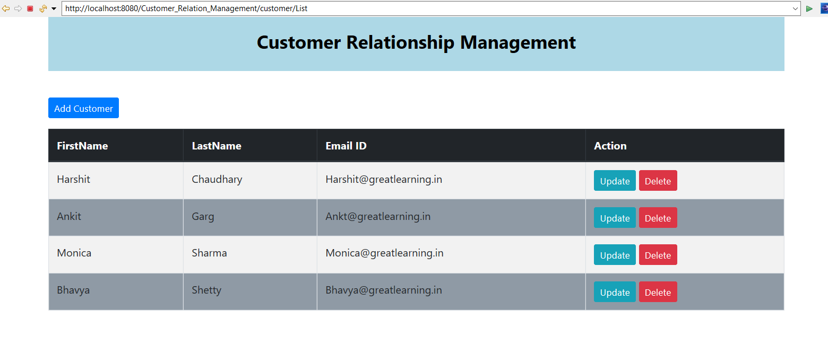

2. Add customer button will redirect to a new page which will consist of a form to add the customer details

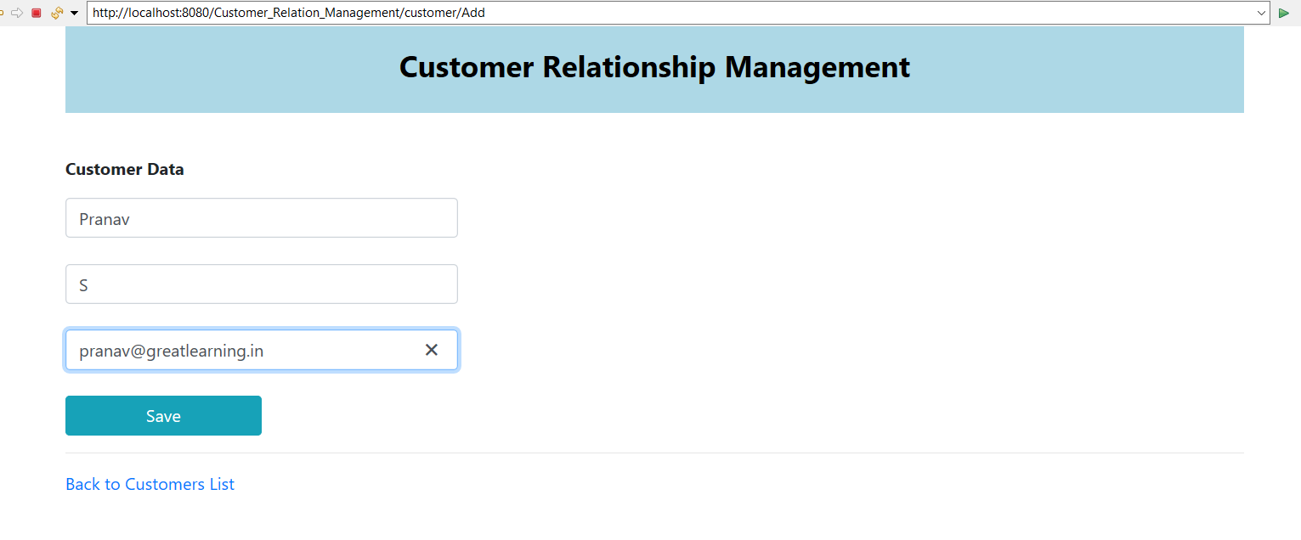

3. Upon Click Add Customer button user will be redirected to a new form page, wherein the user will enter details and save.

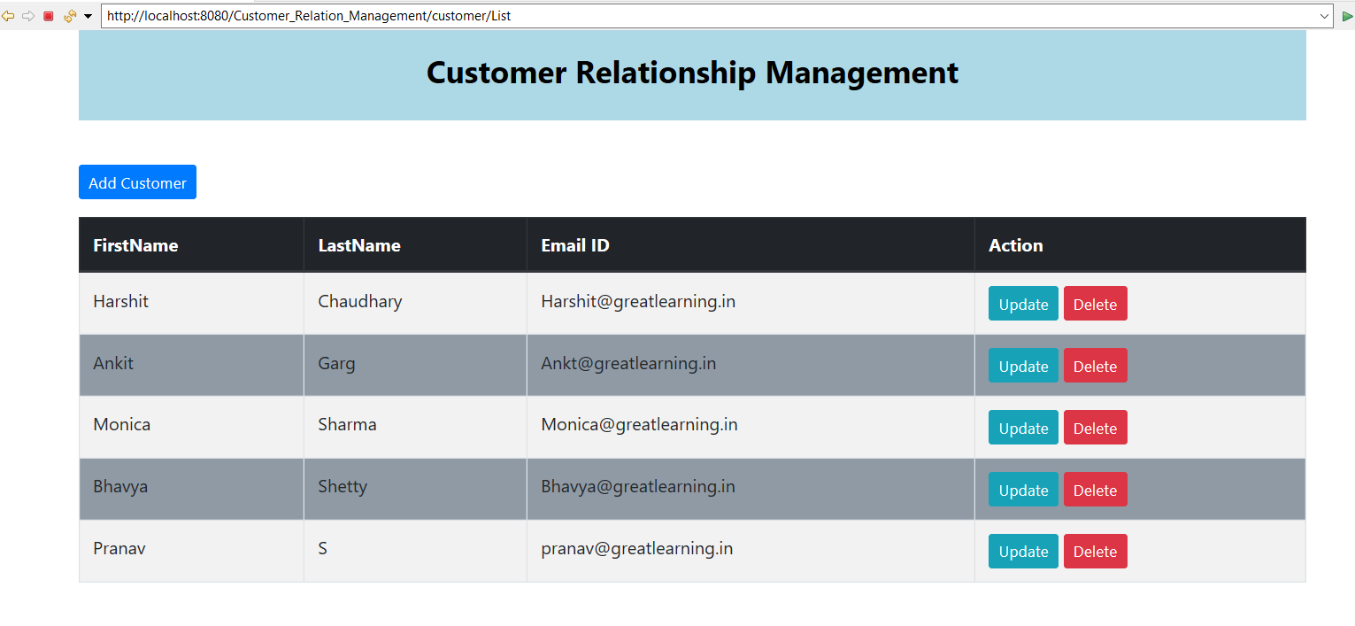

Updated list of customers after adding a new customer Pranav S.

4. Upon clicking the update button the user should be redirected to a new page which will consist of the form same as save page with pre populated data, after updating the details, upon click on save button, new data should persist in the database.

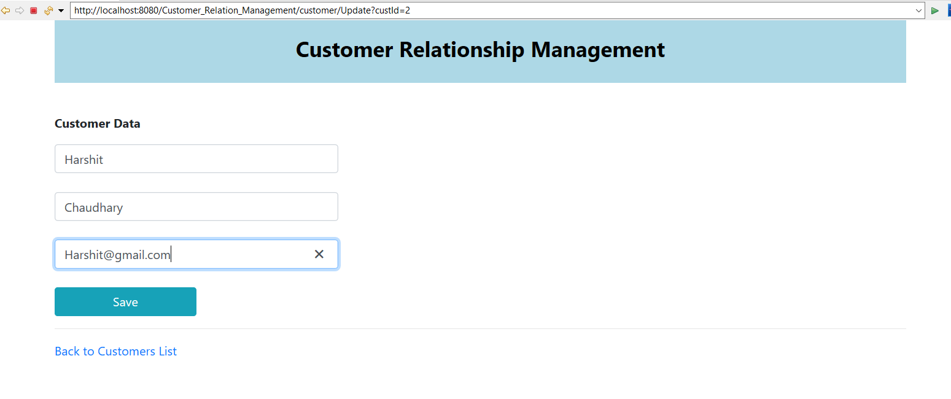

Updating the email address for customer Harshit Choudhary and saving it with address gmail.com

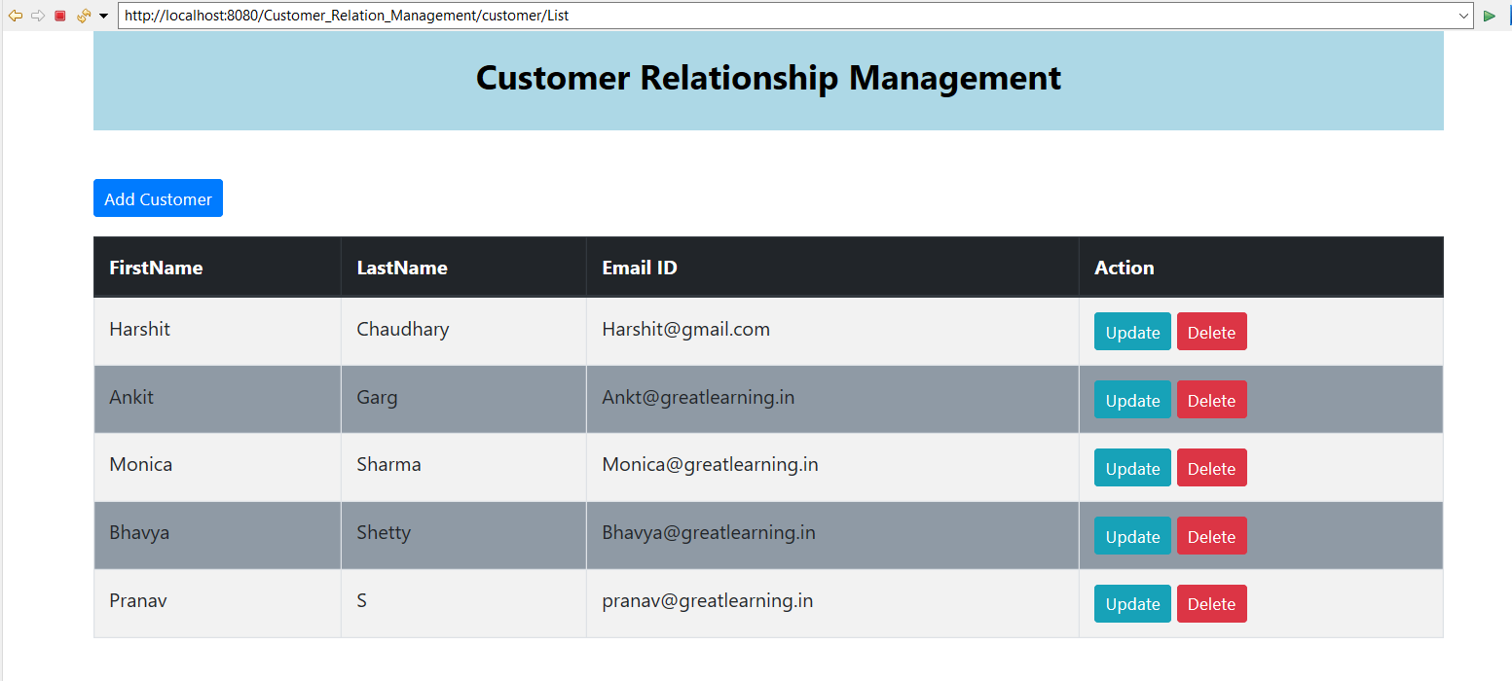

5. Updated value of Customer Harshit Choudhary with email address ending with gmail.com, also upon clicking the delete button, a pop up is generated.

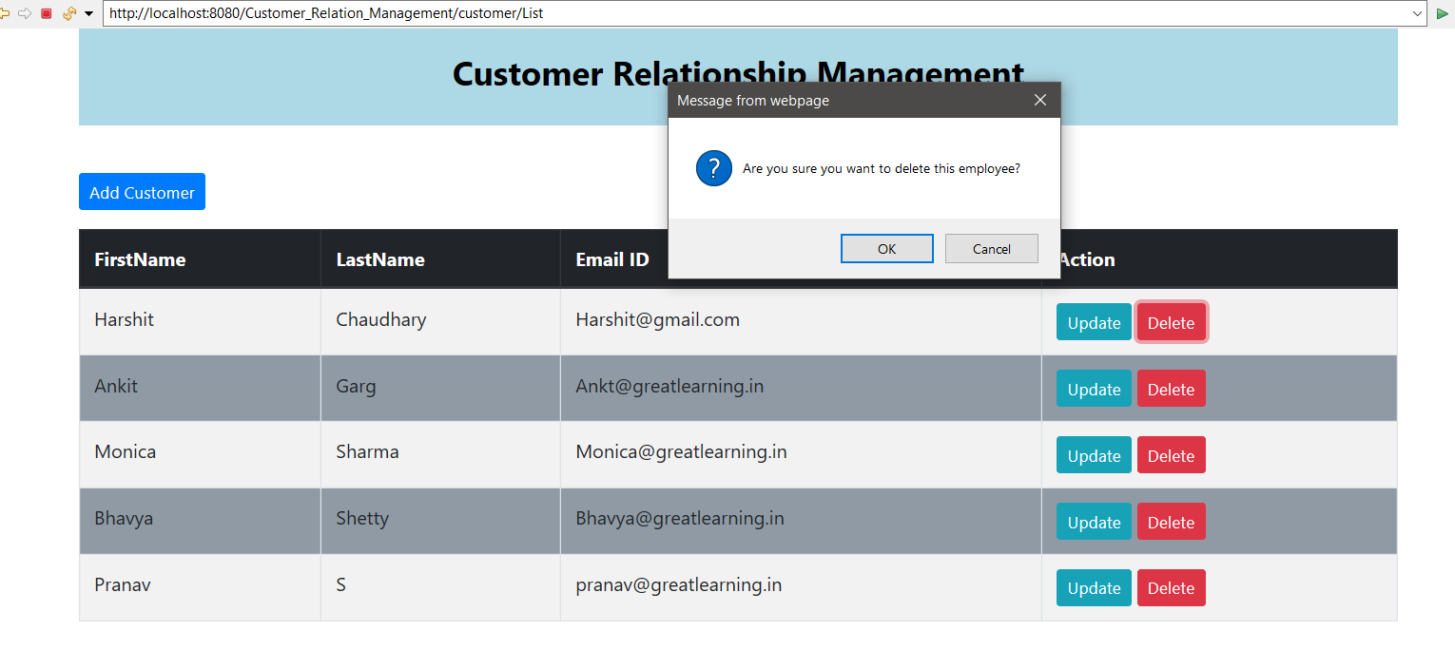

6. Upon clicking on the delete button , the customer entry should get deleted from the

Database.

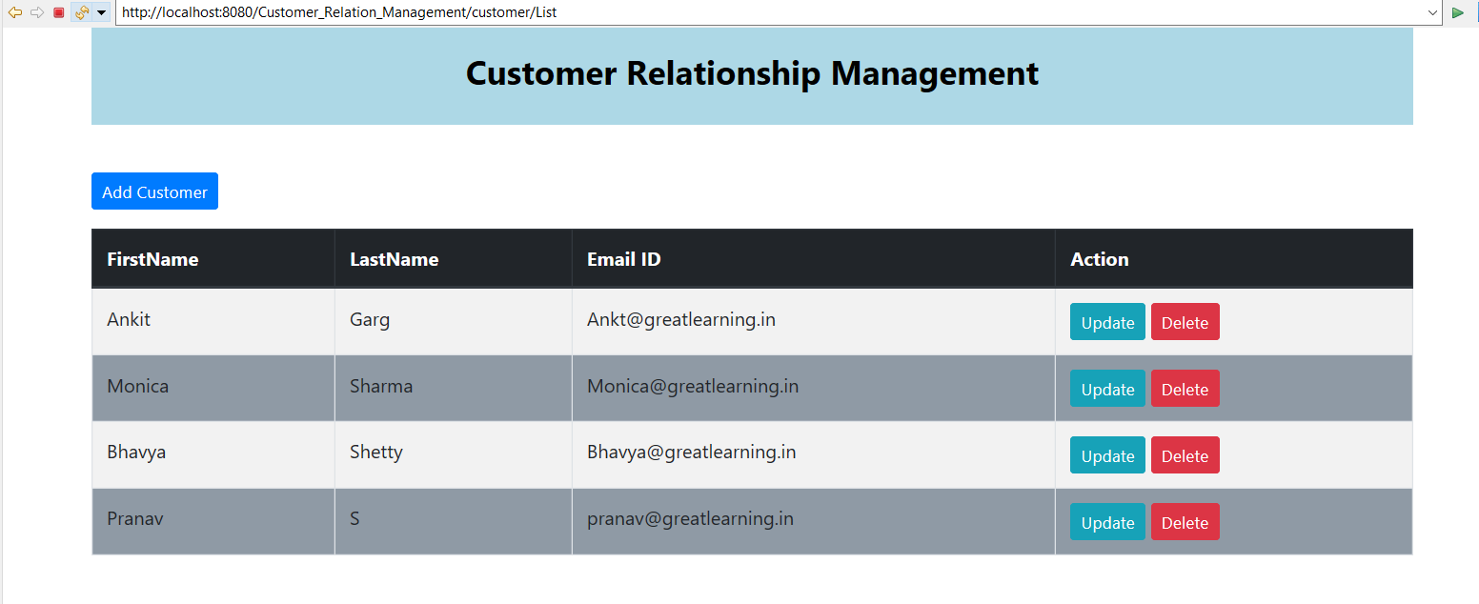

Updated list of employees upon deleting customer Harshit Choudhary.